**Solutions:**

Q1  
**Code:**import cv2

image_path = r"C:\Users\Heisenberg Raja\OneDrive\Documents\Padmanabhan\Slot C\Picture1.png"

image = cv2.imread(image_path)

if image is None:

print("Error: Image not found or unable to load.")

else:

# Step 2: Display the original image

cv2.imshow('Original Image', image)

# Step 3: Convert the image to grayscale

gray_image = cv2.cvtColor(image, cv2.COLOR_BGR2GRAY)

# Step 4: Display the grayscale image

cv2.imshow('Grayscale Image', gray_image)

# Step 5: Wait for a key press and then close the windows

cv2.waitKey(0)

cv2.destroyAllWindows()

Input:  
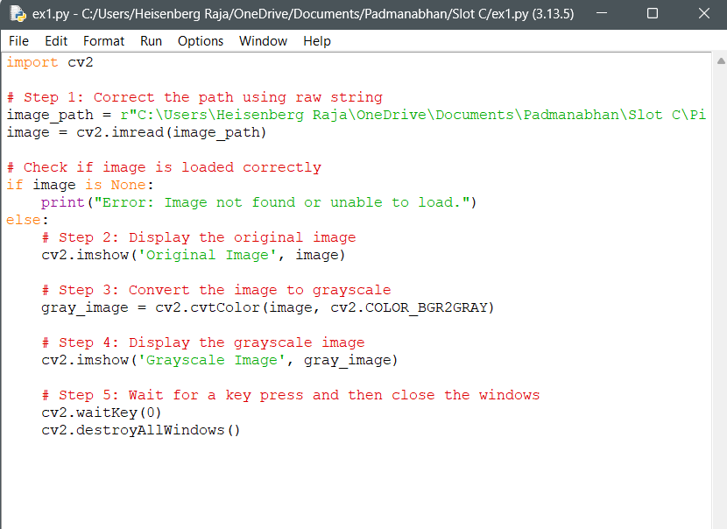

Output:  
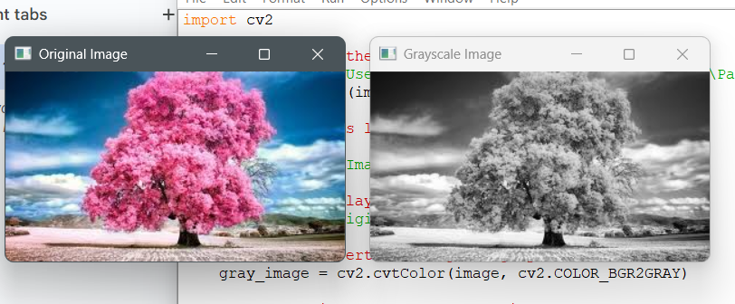

Q2

Code:  
import cv2

# Step 1: Read the image

image_path = r"C:\Users\Heisenberg Raja\OneDrive\Documents\Padmanabhan\Slot C\Picture2.jpg"

image = cv2.imread(image_path)

# Check if image is loaded

if image is None:

print("Error: Image not found or unable to load.")

else:

# Step 2: Display the original image

cv2.imshow("Original Image", image)

# Step 3: Apply Gaussian Blur

# Syntax: cv2.GaussianBlur(src, ksize, sigmaX)

blurred_image = cv2.GaussianBlur(image, (15, 15), 0)

# Step 4: Display the blurred image

cv2.imshow("Blurred Image", blurred_image)

# Step 5: Wait and close

cv2.waitKey(0)

cv2.destroyAllWindows()

Input:  
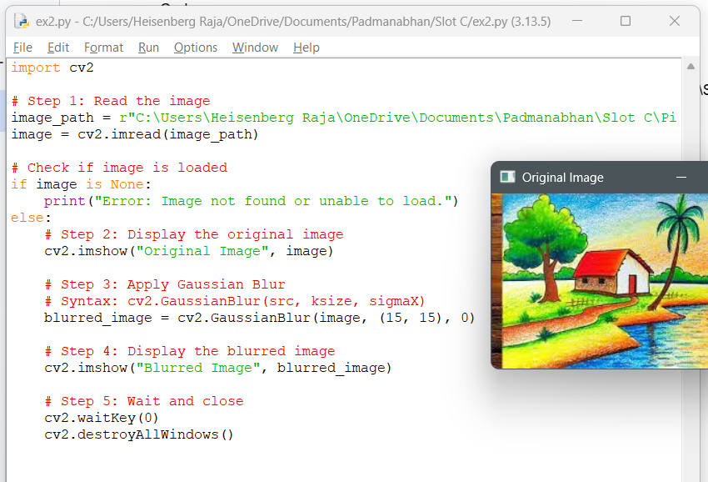

Output:  
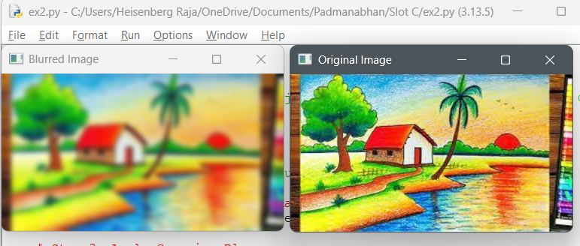

Q3  
Code:  
import cv2

# Step 1: Read the image

image_path = r"C:\Users\Heisenberg Raja\OneDrive\Documents\Padmanabhan\Slot C\Picture3.jpg"

image = cv2.imread(image_path)

# Step 2: Check if image is loaded

if image is None:

print("Error: Image not found or unable to load.")

else:

# Step 3: Convert the image to grayscale

gray_image = cv2.cvtColor(image, cv2.COLOR_BGR2GRAY)

# Step 4: Apply Canny edge detection

# Syntax: cv2.Canny(image, threshold1, threshold2)

edges = cv2.Canny(gray_image, threshold1=100, threshold2=200)

# Step 5: Display original and edge-detected image

cv2.imshow("Original Image", image)

cv2.imshow("Edge Detected (Canny)", edges)

# Step 6: Wait for key press and close windows

cv2.waitKey(0)

cv2.destroyAll

Input:  
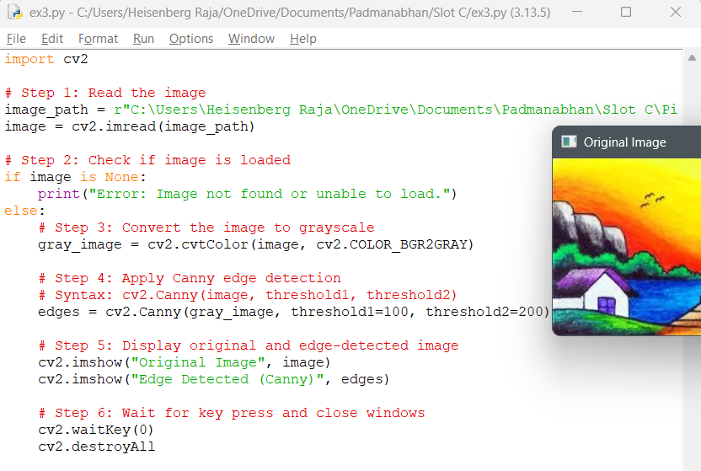

Output:  
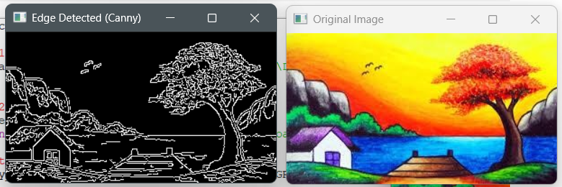

Q4:  
Code:

import cv2

import numpy as np

# Step 1: Read the image

image_path = r"C:\Users\Heisenberg Raja\OneDrive\Documents\Padmanabhan\Slot C\Picture4.jpg"

image = cv2.imread(image_path)

# Step 2: Check if image is loaded

if image is None:

print("Error: Image not found or unable to load.")

else:

# Step 3: Convert image to grayscale

gray_image = cv2.cvtColor(image, cv2.COLOR_BGR2GRAY)

# Step 4: Create a kernel for dilation (e.g., 5x5 matrix of ones)

kernel = np.ones((5, 5), np.uint8)

# Step 5: Apply dilation

dilated_image = cv2.dilate(gray_image, kernel, iterations=1)

# Step 6: Display original and dilated images

cv2.imshow("Original Image", image)

cv2.imshow("Dilated Image", dilated_image)

# Step 7: Wait and close

cv2.waitKey(0)

cv2.destroyAllWindows()

Input:  
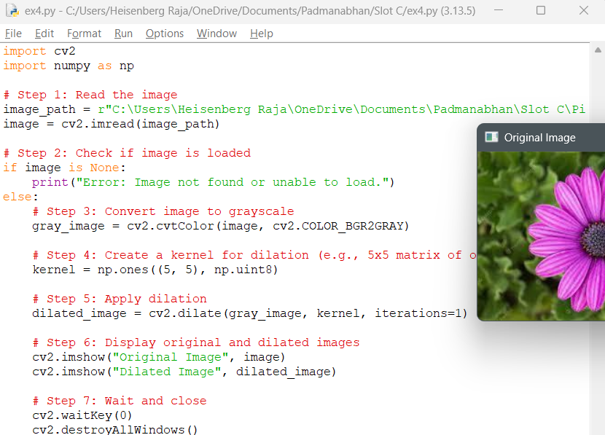

Output:  
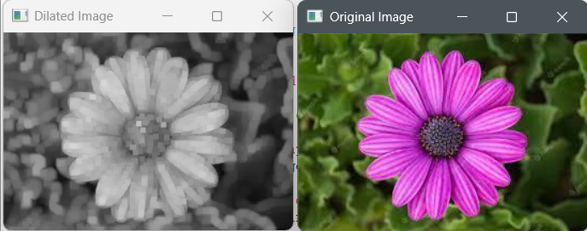

Q5  
Code:

import cv2

import numpy as np

# Read the image

image = cv2.imread("pic.jpeg")

# Convert to grayscale (erosion works better in single channel)

gray = cv2.cvtColor(image, cv2.COLOR_BGR2GRAY)

# Define kernel for erosion

kernel = np.ones((5, 5), np.uint8)

# Erode the image

eroded_image = cv2.erode(gray, kernel, iterations=1)

# Show the original and eroded images

cv2.imshow("Original Image", image)

cv2.imshow("Grayscale Image", gray)

cv2.imshow("Eroded Image", eroded_image)

# Wait and close windows

cv2.waitKey(0)

cv2.destroyAllWindows()

Input:  
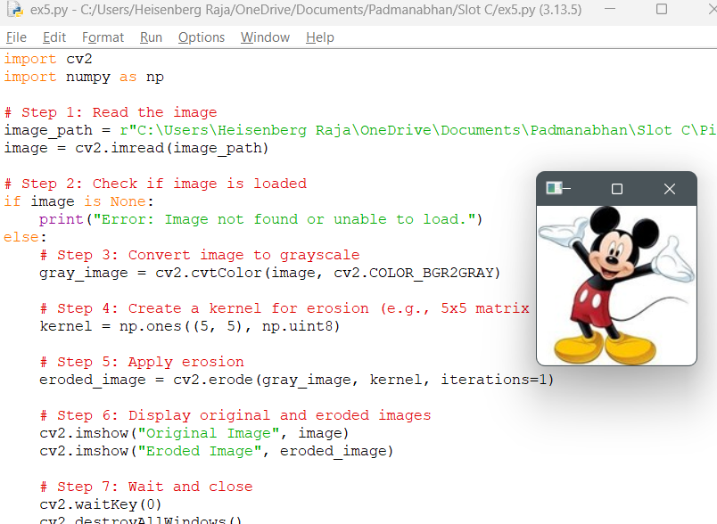

Output:  
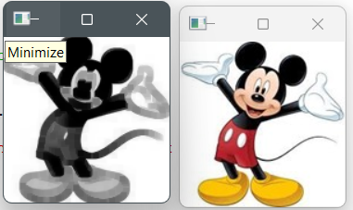

Q6  
Code:

import cv2

# Step 1: Read the video file

video_path = r"C:\Users\Heisenberg Raja\OneDrive\Documents\Padmanabhan\Slot C\sample_video.mp4"

cap = cv2.VideoCapture(video_path)

# Check if video opened successfully

if not cap.isOpened():

print("Error: Cannot open video.")

else:

print("Playing video...")

# Step 2: Get the original frame rate (fps)

fps = int(cap.get(cv2.CAP_PROP_FPS))

print("Original FPS:", fps)

# ----- NORMAL SPEED -----

while cap.isOpened():

ret, frame = cap.read()

if not ret:

break

cv2.imshow("Normal Speed", frame)

if cv2.waitKey(int(1000 / fps)) & 0xFF == ord('q'): # Normal speed

break

cap.set(cv2.CAP_PROP_POS_FRAMES, 0) # Reset to start

# ----- SLOW MOTION (delay more) -----

print("Playing in slow motion...")

while cap.isOpened():

ret, frame = cap.read()

if not ret:

break

cv2.imshow("Slow Motion", frame)

if cv2.waitKey(int(1000 / (fps / 0.5))) & 0xFF == ord('q'): # Half speed

break

cap.set(cv2.CAP_PROP_POS_FRAMES, 0) # Reset to start

# ----- FAST MOTION (delay less) -----

print("Playing in fast motion...")

while cap.isOpened():

ret, frame = cap.read()

if not ret:

break

cv2.imshow("Fast Motion", frame)

if cv2.waitKey(int(1000 / (fps * 2))) & 0xFF == ord('q'): # Double speed

break

# Step 3: Release the video and close windows

cap.release()

cv2.destroyAllWindows()

Input:

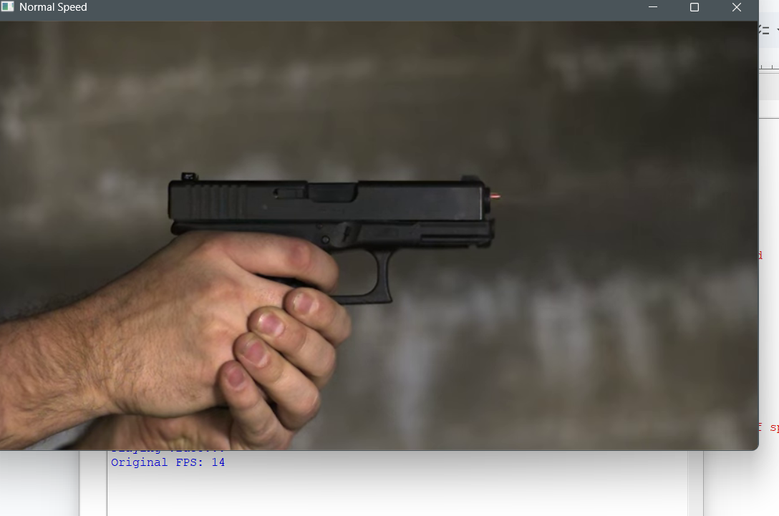

Output:

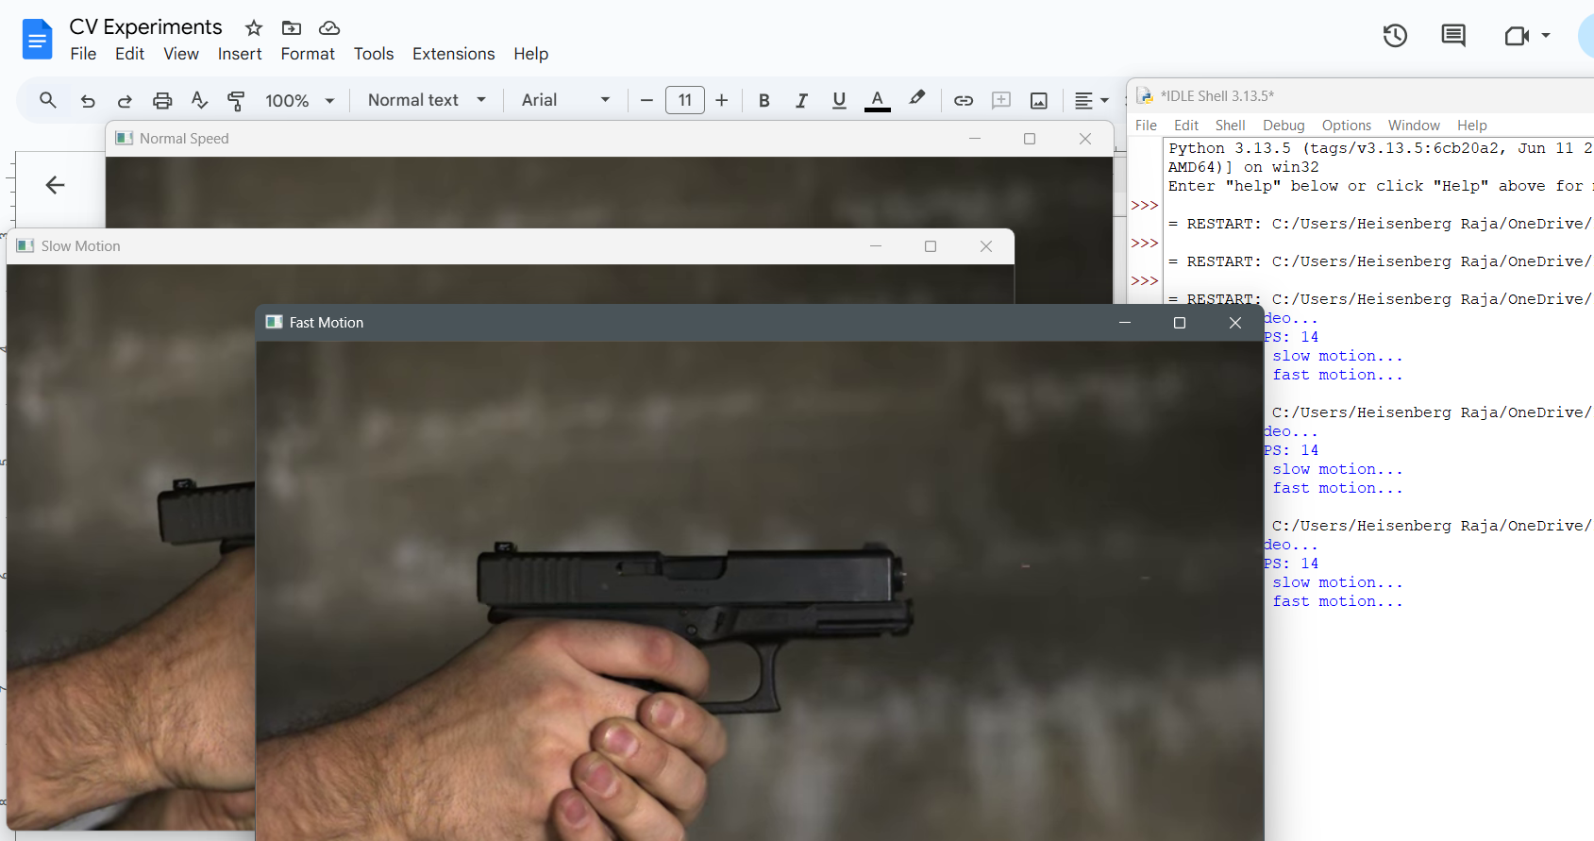

Q8

Code:

import cv2

# Step 1: Read the image

image_path = r"C:\Users\Heisenberg Raja\OneDrive\Documents\Padmanabhan\Slot C\Picture1.png"

image = cv2.imread(image_path)

# Step 2: Check if image is loaded

if image is None:

print("Error: Image not found or unable to load.")

else:

# Step 3: Get original dimensions

height, width = image.shape[:2]

print(f"Original Size: {width}x{height}")

# Step 4: Resize to bigger size (e.g., 2x scale)

bigger_image = cv2.resize(image, (width * 2, height * 2), interpolation=cv2.INTER_LINEAR)

# Step 5: Resize to smaller size (e.g., 0.5x scale)

smaller_image = cv2.resize(image, (width // 2, height // 2), interpolation=cv2.INTER_AREA)

# Step 6: Display all images

cv2.imshow("Original Image", image)

cv2.imshow("Bigger Image (2x)", bigger_image)

cv2.imshow("Smaller Image (0.5x)", smaller_image)

# Step 7: Wait for key press and close

cv2.waitKey(0)

cv2.destroyAllWindows()

Input:  
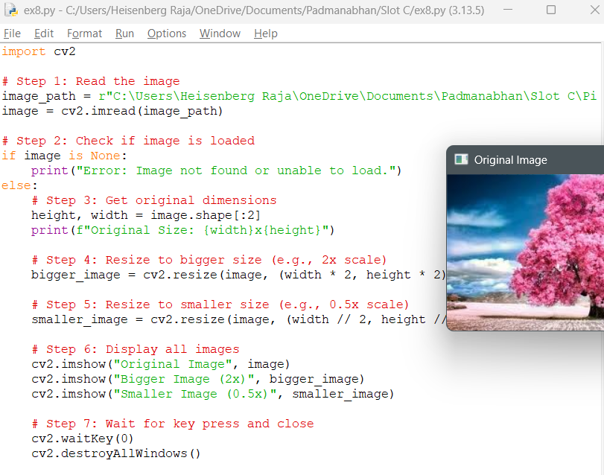

Output:  
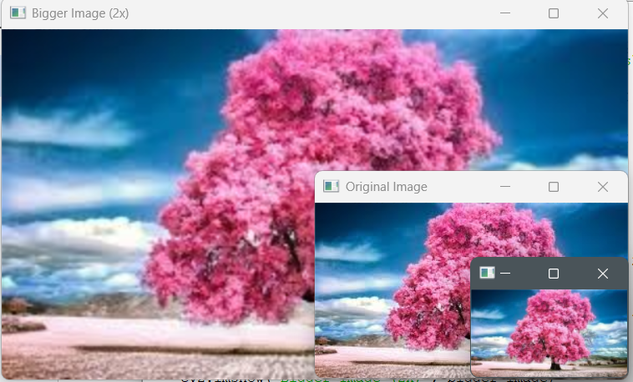

Q9:  
Code:  
import cv2

# Step 1: Read the image

image_path = r"C:\Users\Heisenberg Raja\OneDrive\Documents\Padmanabhan\Slot C\Picture1.png"

image = cv2.imread(image_path)

# Step 2: Check if image loaded

if image is None:

print("Error: Image not found or unable to load.")

else:

# Step 3: Rotate 90 degrees clockwise

rotated_cw = cv2.rotate(image, cv2.ROTATE_90_CLOCKWISE)

# Step 4: Rotate 90 degrees counter-clockwise

rotated_ccw = cv2.rotate(image, cv2.ROTATE_90_COUNTERCLOCKWISE)

# Step 5: Display the images

cv2.imshow("Original Image", image)

cv2.imshow("Rotated Clockwise (90°)", rotated_cw)

cv2.imshow("Rotated Counter-Clockwise (90°)", rotated_ccw)

# Step 6: Wait for key press and close

cv2.waitKey(0)

cv2.destroyAllWindows()

Input:

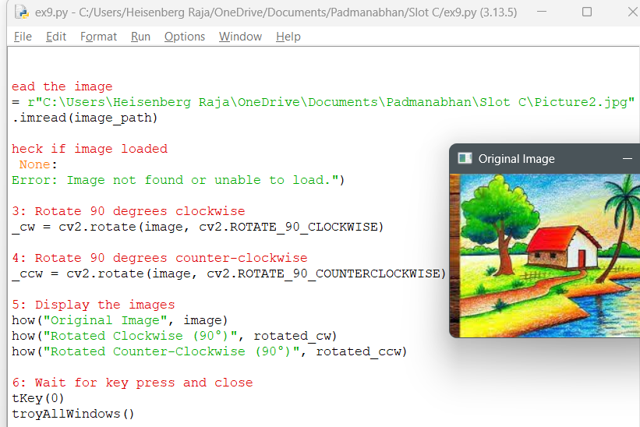

OUT[PUT:

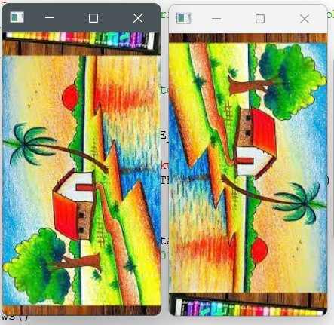

Q10

Code:

import cv2

import numpy as np

# Step 1: Read the image

image_path = r"C:\Users\Heisenberg Raja\OneDrive\Documents\Padmanabhan\Slot C\Picture1.png"

image = cv2.imread(image_path)

# Step 2: Check if image loaded

if image is None:

print("Error: Image not found or unable to load.")

else:

# Step 3: Define the translation (e.g., shift right by 100 px and down by 50 px)

tx = 100 # Shift along X (right)

ty = 50 # Shift along Y (down)

# Step 4: Create the translation matrix

translation_matrix = np.float32([[1, 0, tx],

[0, 1, ty]])

# Step 5: Apply affine transformation (translation)

rows, cols = image.shape[:2]

translated_image = cv2.warpAffine(image, translation_matrix, (cols + tx, rows + ty))

# Step 6: Display images

cv2.imshow("Original Image", image)

cv2.imshow("Translated Image (Moved)", translated_image)

# Step 7: Wait for key press and close

cv2.waitKey(0)

cv2.destroyAllWindows()

Input:

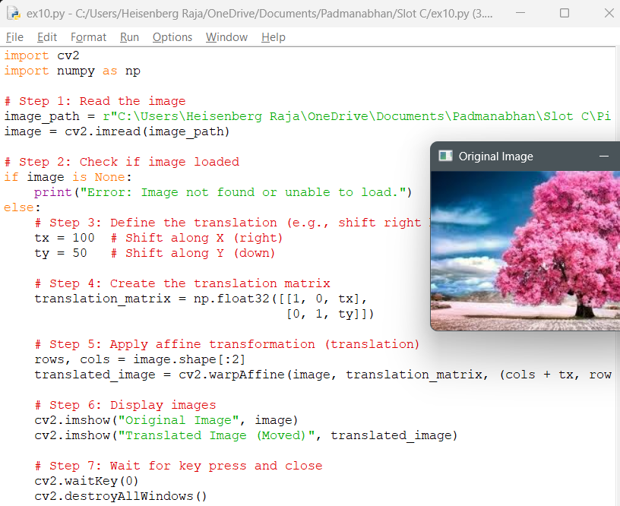

Output:

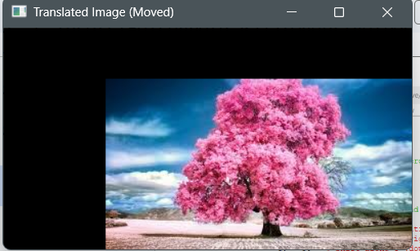

Q11:

Code:

import cv2

import numpy as np

# Step 1: Read the image

image_path = r"C:\Users\Heisenberg Raja\OneDrive\Documents\Padmanabhan\Slot C\Picture1.png"

image = cv2.imread(image_path)

# Step 2: Check if image is loaded

if image is None:

print("Error: Image not found or unable to load.")

else:

# Step 3: Define 3 points from the original image

rows, cols = image.shape[:2]

pts1 = np.float32([[50, 50], [200, 50], [50, 200]])

# Step 4: Define 3 corresponding points in the output image

pts2 = np.float32([[10, 100], [200, 50], [100, 250]])

# Step 5: Get the Affine Transformation matrix

matrix = cv2.getAffineTransform(pts1, pts2)

# Step 6: Apply the Affine Transform

result = cv2.warpAffine(image, matrix, (cols, rows))

# Step 7: Display the original and transformed images

cv2.imshow("Original Image", image)

cv2.imshow("Affine Transformed Image", result)

# Step 8: Wait and close

cv2.waitKey(0)

cv2.destroyAllWindows()

Input:

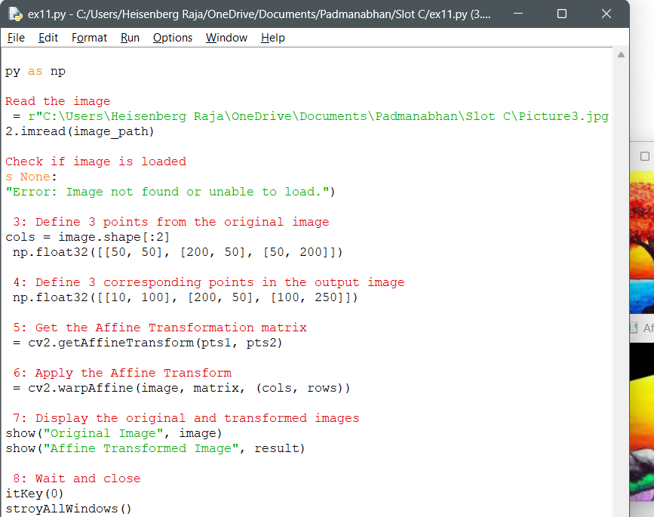

Output:

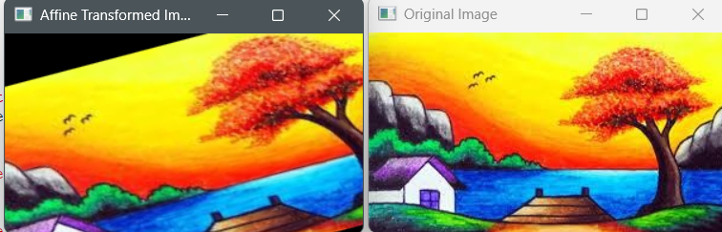

Q12

Code:

import cv2

import numpy as np

# Step 1: Read the image

image_path = r"C:\Users\Heisenberg Raja\OneDrive\Documents\Padmanabhan\Slot C\Picture1.png"

image = cv2.imread(image_path)

# Step 2: Check if image is loaded

if image is None:

print("Error: Image not found or unable to load.")

else:

# Step 3: Define four points in the original image (source points)

pts1 = np.float32([[50, 50], [300, 50], [50, 300], [300, 300]])

# Step 4: Define where those four points should map to in the output image (destination points)

pts2 = np.float32([[10, 100], [300, 50], [100, 300], [290, 290]])

# Step 5: Get the Perspective Transform matrix

matrix = cv2.getPerspectiveTransform(pts1, pts2)

# Step 6: Apply the Perspective Transformation

result = cv2.warpPerspective(image, matrix, (image.shape[1], image.shape[0]))

# Step 7: Display the original and transformed images

cv2.imshow("Original Image", image)

cv2.imshow("Perspective Transformed Image", result)

# Step 8: Wait and close

cv2.waitKey(0)

cv2.destroyAllWindows()

Input:

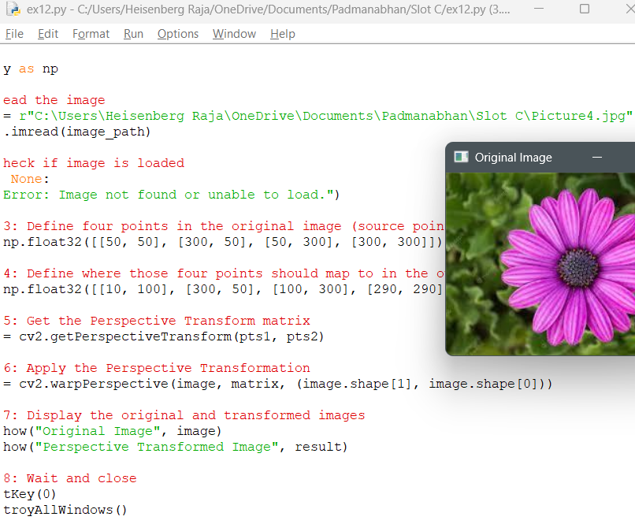

Output:

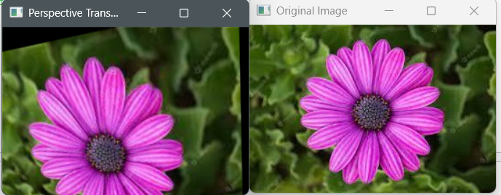

Q13

Code:

import cv2

import numpy as np

# Step 1: Load the video

video_path = r"C:\Users\Heisenberg Raja\OneDrive\Documents\Padmanabhan\Slot C\sample_video.mp4"

cap = cv2.VideoCapture(video_path)

# Step 2: Check if video opened successfully

if not cap.isOpened():

print("Error: Cannot open video.")

else:

print("Performing Perspective Transformation...")

while True:

ret, frame = cap.read()

if not ret:

break

# Step 3: Define 4 source and destination points for perspective transform

h, w = frame.shape[:2]

pts1 = np.float32([[50, 50], [w - 50, 50], [50, h - 50], [w - 50, h - 50]])

pts2 = np.float32([[30, 100], [w - 100, 50], [50, h - 100], [w - 50, h - 50]])

# Step 4: Get perspective transform matrix and apply it

matrix = cv2.getPerspectiveTransform(pts1, pts2)

warped = cv2.warpPerspective(frame, matrix, (w, h))

# Step 5: Display the original and transformed frames

cv2.imshow('Original Video', frame)

cv2.imshow('Perspective Transformed Video', warped)

# Step 6: Press 'q' to quit

if cv2.waitKey(20) & 0xFF == ord('q'):

break

# Step 7: Release and destroy

cap.release()

cv2.destroyAllWindows()

Input:

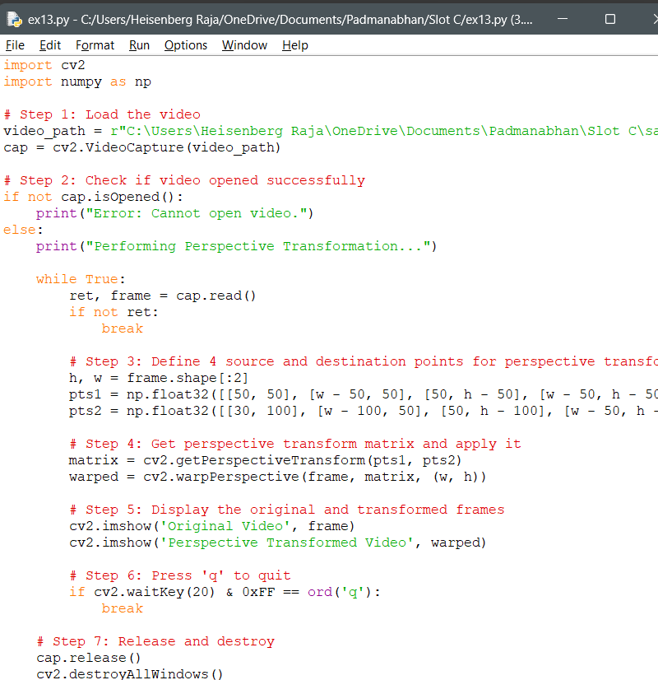

Output:

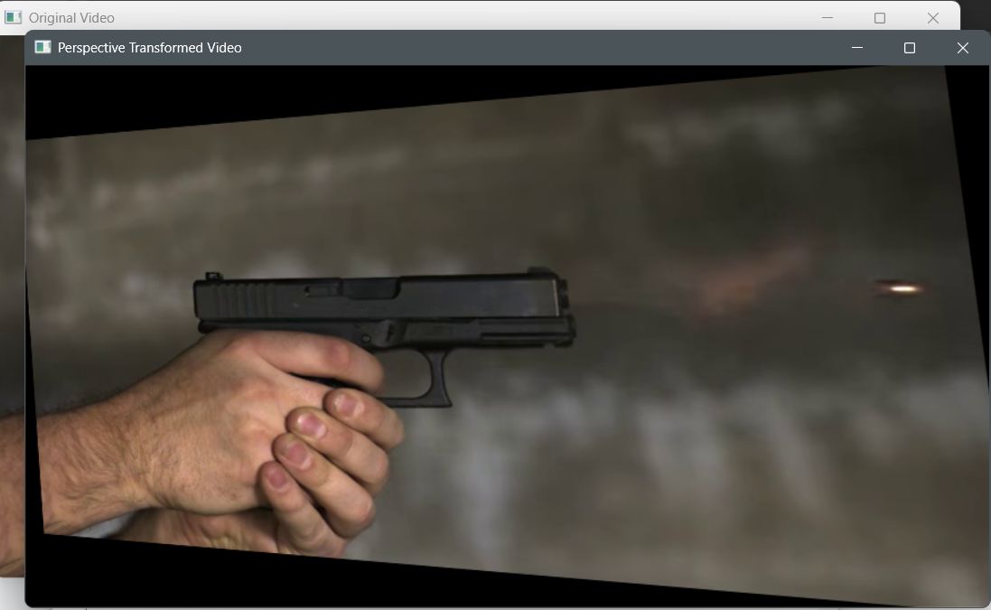

Q14:

Code:

import cv2

import numpy as np

# Step 1: Read the image

image_path = r"C:\Users\Heisenberg Raja\OneDrive\Documents\Padmanabhan\Slot C\Picture1.png"

image = cv2.imread(image_path)

# Step 2: Check if image is loaded

if image is None:

print("Error: Image not found or unable to load.")

else:

# Step 3: Define 4 source and 4 destination points

height, width = image.shape[:2]

src_pts = np.float32([[50, 50], [width - 50, 50], [50, height - 50], [width - 50, height - 50]])

dst_pts = np.float32([[10, 100], [width - 100, 50], [100, height - 100], [width - 50, height - 50]])

# Step 4: Compute Homography matrix

H, status = cv2.findHomography(src_pts, dst_pts)

# Step 5: Apply the homography transformation

transformed_image = cv2.warpPerspective(image, H, (width, height))

# Step 6: Show the original and transformed image

cv2.imshow("Original Image", image)

cv2.imshow("Homography Transformed Image", transformed_image)

# Step 7: Wait and close

cv2.waitKey(0)

cv2.destroyAllWindows()

Input:

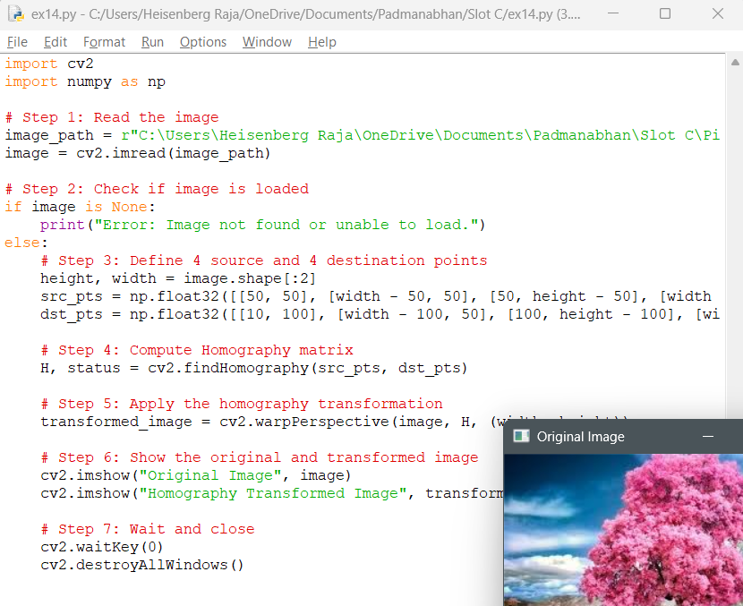

Output:

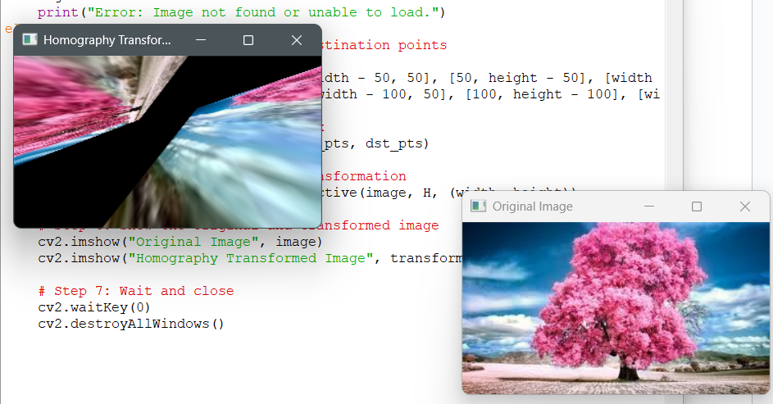

Q15

Code:

import cv2

import numpy as np

def compute_homography_dlt(src_pts, dst_pts):

assert len(src_pts) == len(dst_pts) and len(src_pts) >= 4, "Need at least 4 point pairs"

A = []

for (x, y), (x_prime, y_prime) in zip(src_pts, dst_pts):

A.append([-x, -y, -1, 0, 0, 0, x * x_prime, y * x_prime, x_prime])

A.append([ 0, 0, 0, -x, -y, -1, x * y_prime, y * y_prime, y_prime])

A = np.array(A)

# Solve Ah = 0 using SVD

U, S, Vt = np.linalg.svd(A)

h = Vt[-1, :] / Vt[-1, -1] # Normalize

H = h.reshape(3, 3)

return H

# Step 1: Read the image

image_path = r"C:\Users\Heisenberg Raja\OneDrive\Documents\Padmanabhan\Slot C\Picture1.png"

image = cv2.imread(image_path)

if image is None:

print("Error: Image not found.")

else:

height, width = image.shape[:2]

# Step 2: Define 4 corresponding points

src_pts = np.float32([[50, 50], [width - 50, 50], [50, height - 50], [width - 50, height - 50]])

dst_pts = np.float32([[30, 100], [width - 100, 70], [100, height - 120], [width - 70, height - 70]])

# Step 3: Compute Homography using DLT

H_dlt = compute_homography_dlt(src_pts, dst_pts)

# Step 4: Apply the transformation

transformed_image = cv2.warpPerspective(image, H_dlt, (width, height))

# Step 5: Display the result

cv2.imshow("Original Image", image)

cv2.imshow("DLT Transformed Image", transformed_image)

cv2.waitKey(0)

cv2.destroyAllWindows()

Input:

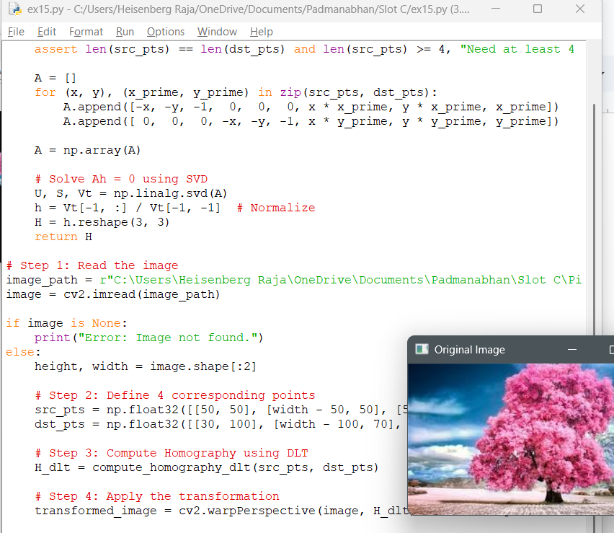

Output:

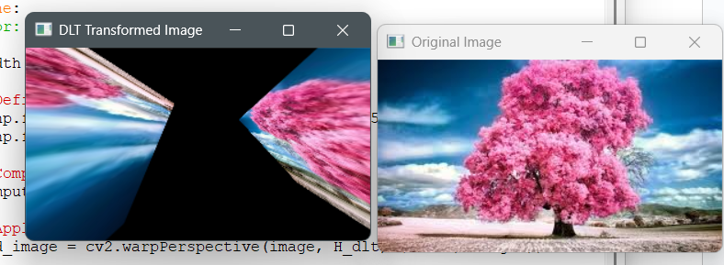

Q16

Code:  
import cv2

# Step 1: Read the image

image_path = r"C:\Users\Heisenberg Raja\OneDrive\Documents\Padmanabhan\Slot C\Picture1.png"

image = cv2.imread(image_path)

# Step 2: Check if image is loaded

if image is None:

print("Error: Unable to load the image.")

else:

# Step 3: Convert to Grayscale (Canny works on grayscale images)

gray = cv2.cvtColor(image, cv2.COLOR_BGR2GRAY)

# Step 4: Apply Canny Edge Detection

# Thresholds can be tuned; typical values: 50 and 150

edges = cv2.Canny(gray, threshold1=50, threshold2=150)

# Step 5: Display the original and edge-detected images

cv2.imshow("Original Image", image)

cv2.imshow("Canny Edge Detection", edges)

# Step 6: Wait and close

cv2.waitKey(0)

cv2.destroyAllWindows()

Input:

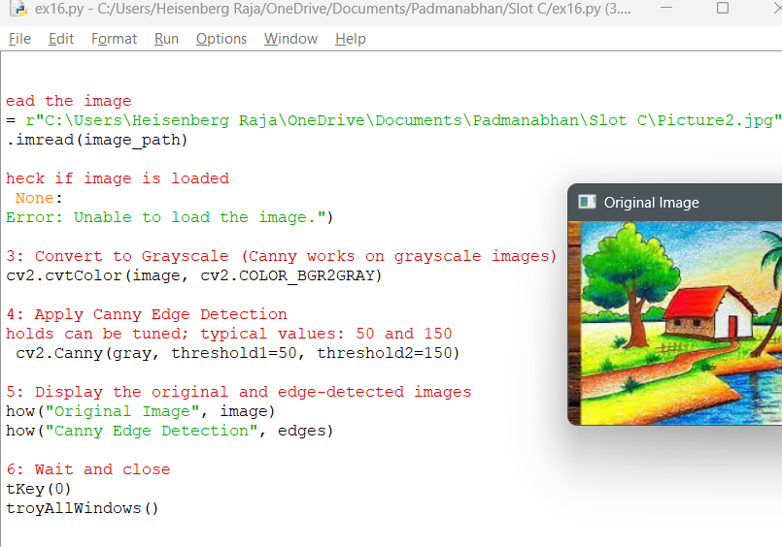

Output:

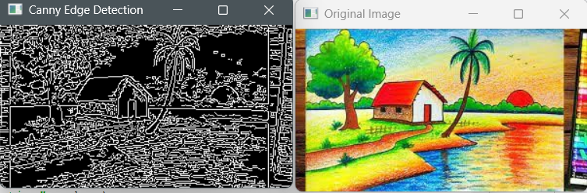

**Q17 & Q18 & Q19**:

Code:

import cv2

import numpy as np

# Step 1: Read the image

image_path = r"C:\Users\Heisenberg Raja\OneDrive\Documents\Padmanabhan\Slot C\Picture1.png"

image = cv2.imread(image_path)

# Step 2: Check if the image is loaded

if image is None:

print("Error: Unable to load image.")

else:

# Step 3: Convert to Grayscale

gray = cv2.cvtColor(image, cv2.COLOR_BGR2GRAY)

# Step 4: Sobel X (vertical edges)

sobel_x = cv2.Sobel(gray, cv2.CV_64F, 1, 0, ksize=3)

sobel_x = cv2.convertScaleAbs(sobel_x)

# Step 5: Sobel Y (horizontal edges)

sobel_y = cv2.Sobel(gray, cv2.CV_64F, 0, 1, ksize=3)

sobel_y = cv2.convertScaleAbs(sobel_y)

# Step 6: Combine Sobel X and Y using bitwise OR (XY edges)

sobel_xy = cv2.bitwise_or(sobel_x, sobel_y)

# Step 7: Show all results

cv2.imshow("Original Image", image)

cv2.imshow("Sobel X - Vertical Edges", sobel_x)

cv2.imshow("Sobel Y - Horizontal Edges", sobel_y)

cv2.imshow("Sobel XY - Combined Edges", sobel_xy)

# Step 8: Wait and close

cv2.waitKey(0)

cv2.destroyAllWindows()

Input:

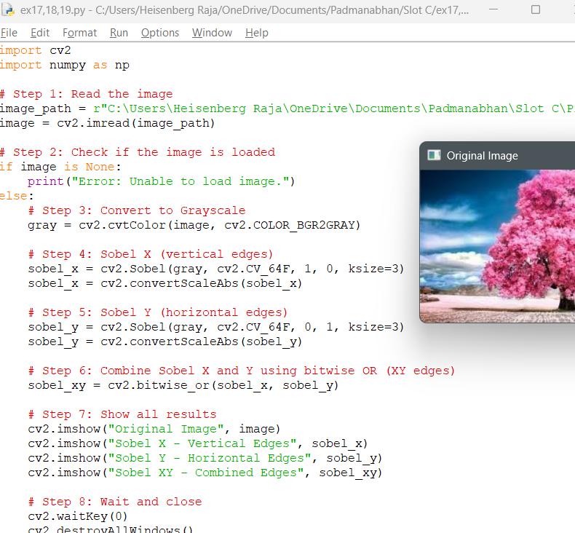

Output:

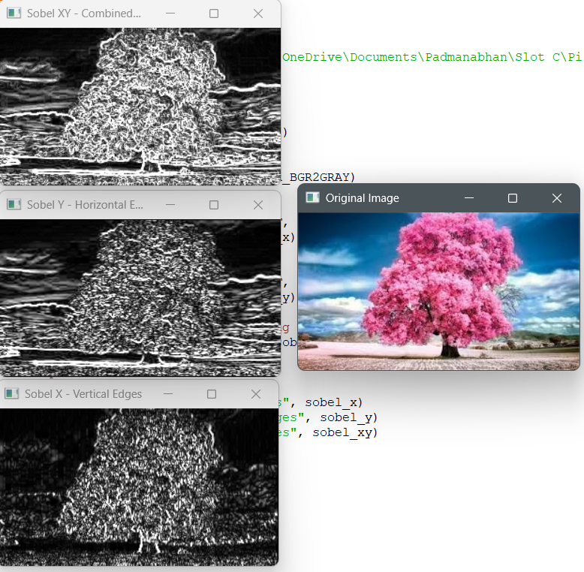

**Q20**

Code:

import cv2

import numpy as np

# Load the image

image_path = r"C:\Users\Heisenberg Raja\OneDrive\Documents\Padmanabhan\Slot C\Picture1.png"

image = cv2.imread(image_path)

if image is None:

print("Error: Unable to load image.")

else:

# Convert to grayscale for sharpening

gray = cv2.cvtColor(image, cv2.COLOR_BGR2GRAY)

# Define Laplacian kernel with negative center

laplacian_kernel = np.array([[0, 1, 0],

[1, -4, 1],

[0, 1, 0]])

# Apply the Laplacian kernel to the grayscale image

laplacian = cv2.filter2D(gray, cv2.CV_64F, laplacian_kernel)

laplacian = cv2.convertScaleAbs(laplacian)

# Sharpened image = original - laplacian

sharpened = cv2.subtract(gray, laplacian)

# Show images

cv2.imshow("Original Grayscale", gray)

cv2.imshow("Laplacian (Edges)", laplacian)

cv2.imshow("Sharpened Image", sharpened)

cv2.waitKey(0)

cv2.destroyAllWindows()

Input:

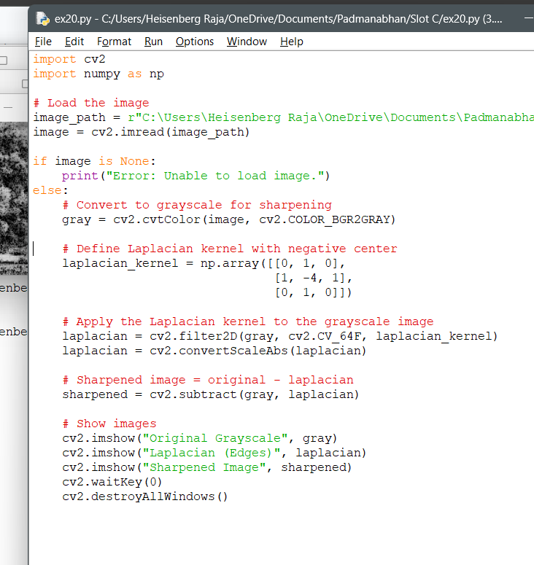

Output:

